Chris Cordaro
HW 4

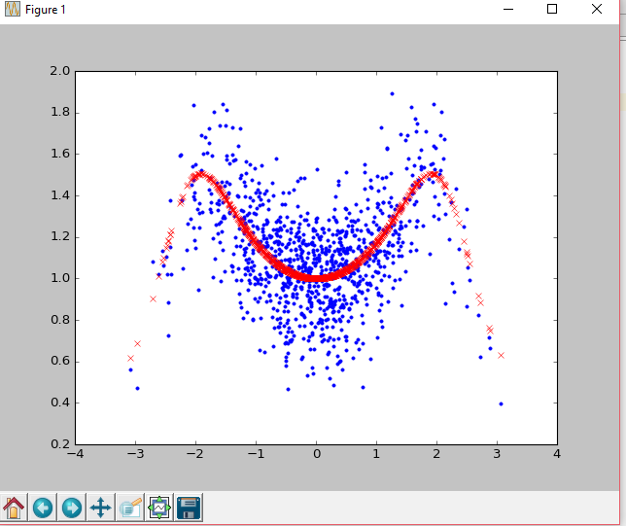

results of 1NN:

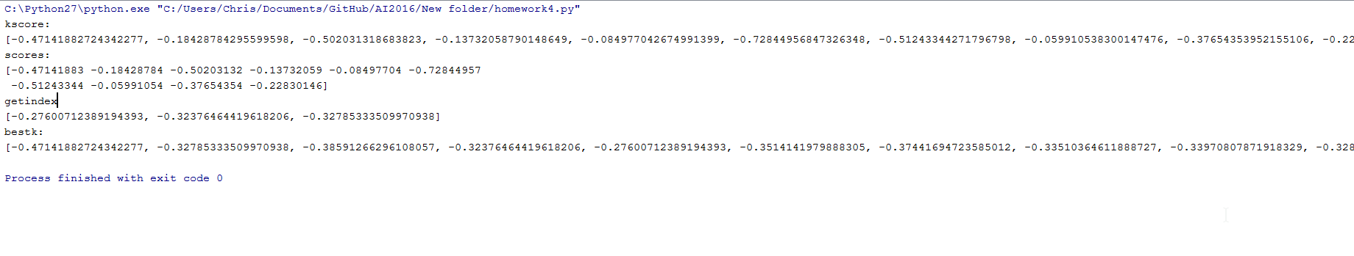

Results for 3NN
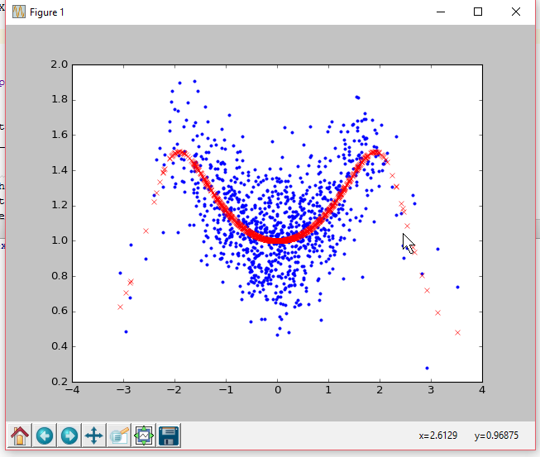

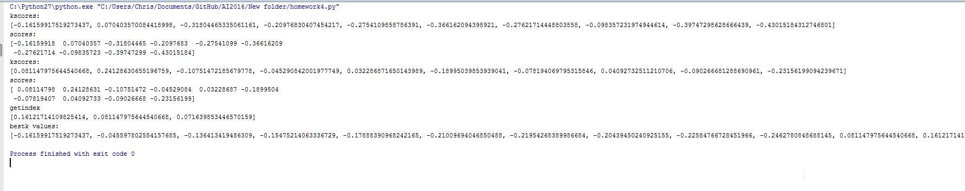

bestk values:
[-0.56546180911988997, -0.539809349975648, -0.41968642402032796, -0.38308153457616112, -0.35755776684967372, -0.32650695977677041, -0.28556531826855236, -0.31378015460911968, -0.32650869779800562, -0.30815274342892146, -0.16749857254467182, -0.16465428461060372, -0.079938940397109429, -0.062703727030966439, -0.070066983801475843, -0.02484058458127299, -0.013597633333646291, -0.045405819301559, -0.057284598626206065, -0.058661066316047825]

Process finished with exit code 0

Results for 5NN
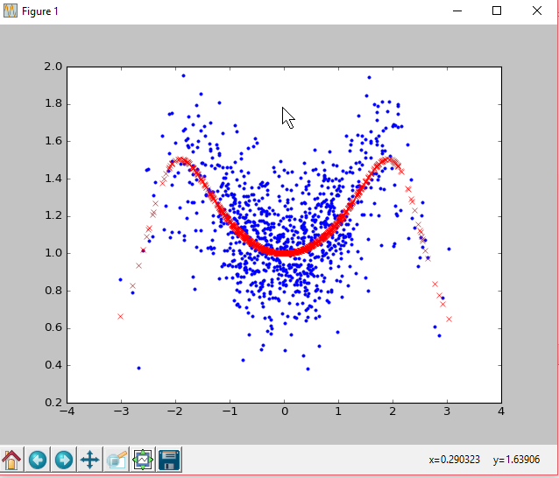

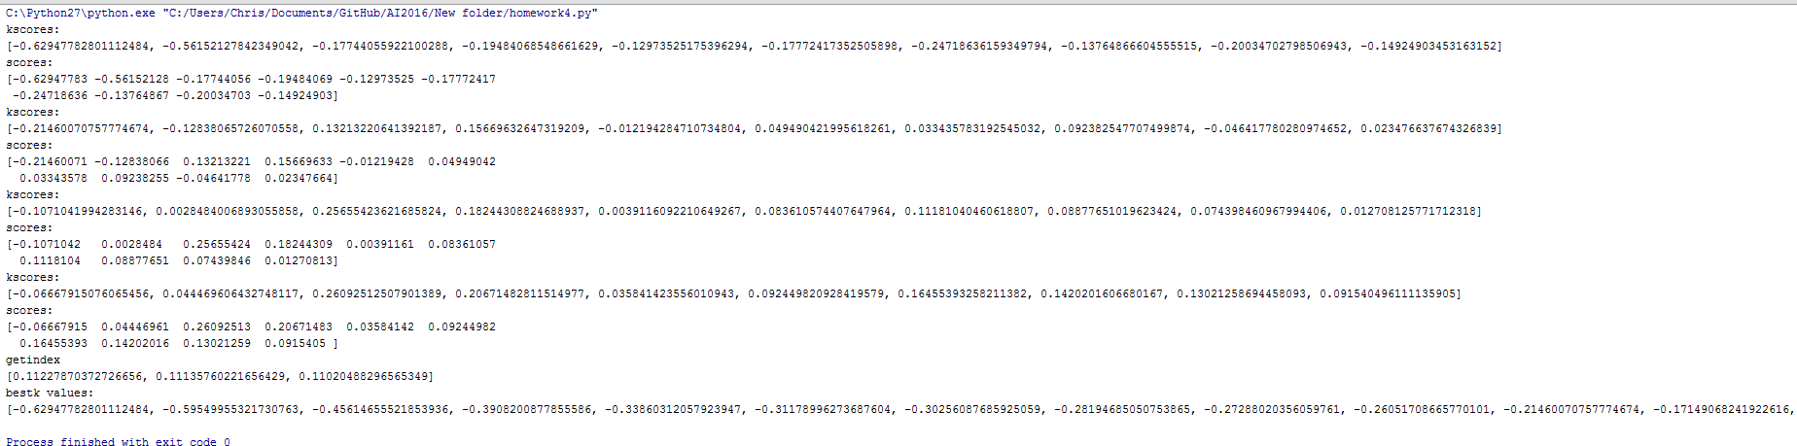

bestk values:
[-0.62947782801112484, -0.59549955321730763, -0.45614655521853936, -0.3908200877855586, -0.33860312057923947, -0.31178996273687604, -0.30256087685925059, -0.28194685050753865, -0.27288020356059761, -0.26051708665770101, -0.21460070757774674, -0.17149068241922616, -0.070283052808176816, -0.013538207987834588, -0.013269423332414631, -0.002809449111075816, 0.0023684412180128766, 0.013620204529198751, 0.0069493173280683728, 0.0086020493626942189, -0.1071041994283146, -0.052127899369504509, 0.050766145825949738, 0.083685381431184647, 0.0677306269891607, 0.070377284892241918, 0.07629630199423422, 0.077856328019484222, 0.077472120569318681, 0.070995721089558053, -0.06667915076065456, -0.011104772163953221, 0.07957186025036915, 0.11135760221656429, 0.096254366484453624, 0.095620275558447945, 0.10546794084754307, 0.11003696832510228, 0.11227870372726656, 0.11020488296565349]

for 999 neighbors I got this error
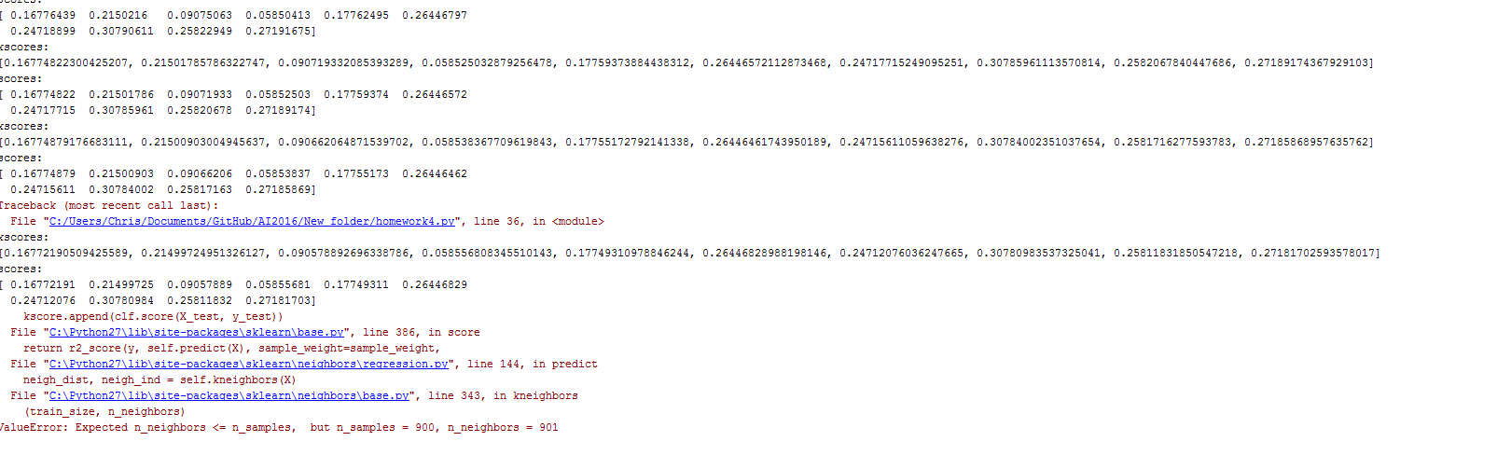
I’m not quite sure why this would happen considering it seemed to stop at the 900th neighbor and not a seemingly significant number like 998.

